OFFICIAL COORDINATION REQUEST FOR NON- ROUTINE OPERATIONS AND MAINTENANCE

COORDINATION TITLE- 16BON17 PH1 and PH2 intake deck spalling repair
COORDINATION DATE- 31 May 2016
PROJECT- BONNEVILLE Lock and Dam
RESPONSE DATE- XX June 2016

Description of the problem- Spalling on the intake (+90) decks of both powerhouses is in need of repair. At PH2 the spalling has resulted in water leaking into the Visitors’ Gallery inside the powerhouse. The repairs would occur at 1 location at each powerhouse. There are more locations that will need to be addressed soon but another MOC will be sent at a later date for those repairs. The repairs would require making a 1.5 to 2” sawcut around each spall, chipping out unsound concrete, powerwashing, and then replacing the concrete. Sawcutting would take approximately 1 hour per spall. BON Project would like to conduct the repairs during fair weather and during the nadir between spring and summer juvenile salmonid outmigrations.

Type of outage required- None.

Impact on facility operation- None.

Dates of impacts/repairs- 2 days, occurring between 01 and 20 June 2016.

Length of time for repairs- Half day per joint, one half-day for PH2 and one half day for PH1..

Expected impacts on fish passage-
Bull Trout-
Of the five distinct population segments (DPS) of bull trout listed as threatened by the USFWS, the Columbia River DPS is the only one that is likely to occur in the vicinity of the proposed project. Historically, bull trout of the Columbia River DPS likely ranged through much of the Columbia River Basin with spawning and rearing occurring in the coldest creeks, often at higher elevations. Presently, bull trout of the Columbia River DPS are distributed in a more fragmented pattern throughout the Columbia River Basin with fewer adult migratory fish and fewer, more compressed spawning reaches than historically occurred.

WDFW and Corps personnel provided a list of anecdotal sightings/captures of bull trout in the mainstem Columbia River. From 2000 through 2012 there were eleven bull trout reported. Three were downstream of Bonneville Dam, with two at the mouth of Hamilton Creek (RM 143) and one in 2005 at the Bonneville Dam Smolt Monitoring Facility (RM 144). Upstream of the dam, one bull trout was found at Cascade Locks (RM 149), two at Drano Lake (RM 162), two at the mouth of the Klickatat River (RM 180.5), one in 2002 at the John Day Dam Smolt Monitoring Facility (RM 215), and one sighting at Dog Creek Falls by a reputable WDFW creel sampler who observed 18- to 24-inch cuts or dollies working old redds below the splash pool over the course of two weeks.

Fish passage data from the Bonneville Dam fish ladders (Corps, unpublished) show only three sightings of bull trout moving through the fish ladders for 2000 through 2011 during the fish counting season (April 1 through October 31). These sightings occurred between May 30, 2009 and June 2, 2009 and were reported as ‘12-inch bull trout moving upstream’ through the count window on each occasion.

Downstream passage-
The joint repairs will occur on the intake decks above the DSM at PH2 and the ITS at PH1. Some noise from sawcutting may filter through the deck; however the repairs will be timed to occur during the nadir in downstream juvenile passage (Figure 1).
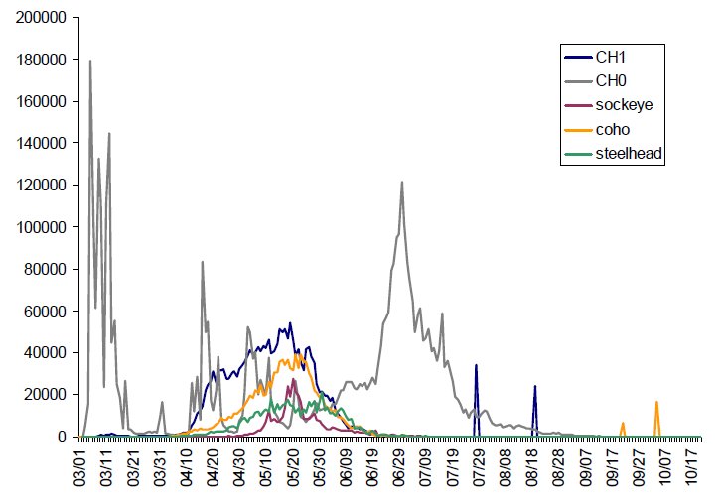
Figure 1: Run timing for juvenile salmonid species taken from BON SMF index estimates, averaged from 1998-2008. Taken from Carter et al. (2009).

Upstream passage-
Repairs will not be occurring near any adult fishways and impacts are not expected.

Reference:
Carter JA, McMichael GA, Welch ID, Harnish RA, Bellgraph BJ. 2009. Seasonal juvenile salmonid presence and migration timing in the Lower Columbia River. PNNL report to USACE, PNNL-18246.

Comments from agencies

Final results-

Please email or call with questions or concerns.
Thank you,
Tammy

Tammy Mackey
NWP Operations Division Fishery Section
Columbia River Coordination Biologist
503-961-5733
Tammy.m.mackey@usace.army.mil

